My Angles Booklet
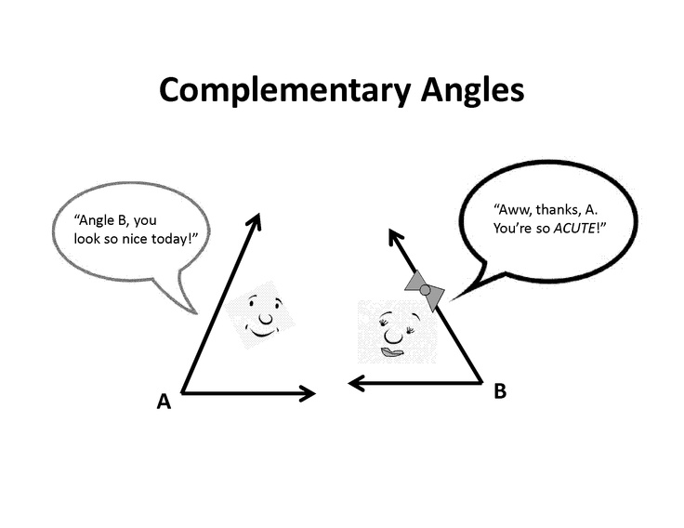

Name: _____

Label the angle:
(arm, vertex, angle)

Name the types of angles:

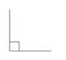  Name: | 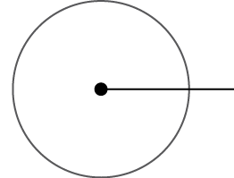  Name: | 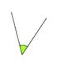  Name:
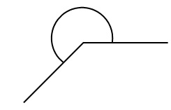  Name: | 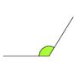  Name: | 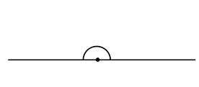  Name:

Draw the following angles:

Acute Angle = 40° Obtuse Angle = 130°

Find 10 different angles on the stick man:

Draw the following angle:

Reflex angle = 220°

Work out the Vertically Opposite angle:

1.
A=
a°
68°

B=
b°
2.
26°

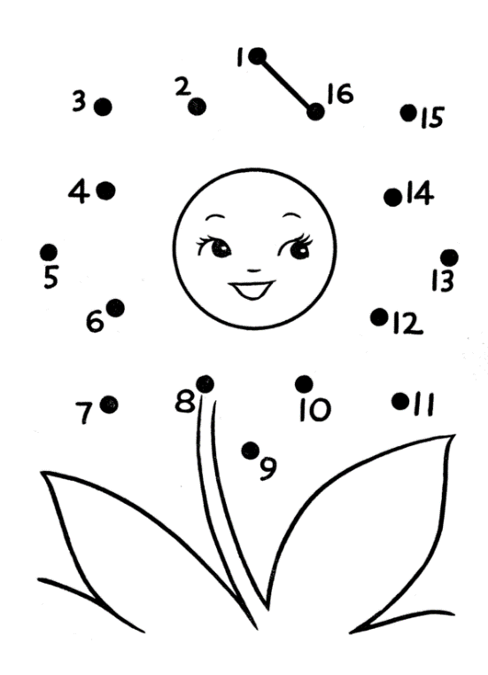

c°
3.
C=
60°
d°
120°
D=

Work out the Supplementary angles:
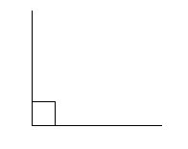
B=
A=
d°
37°
22°
a°

Work out the Complementary angles:

1.
A=
a°
140°

2.
B=
58°
b°

Work out the Angles at point:
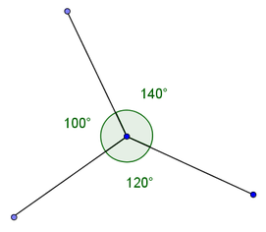
1.
A=
a°

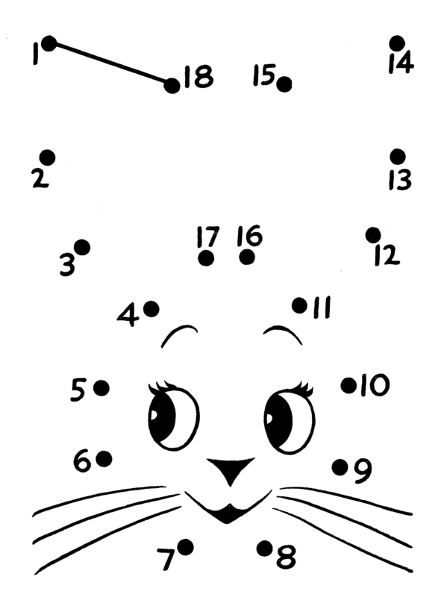

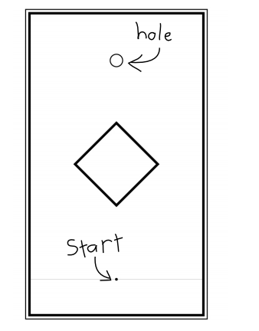
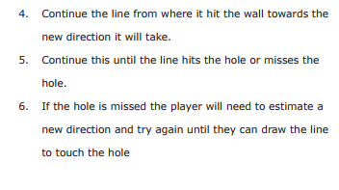
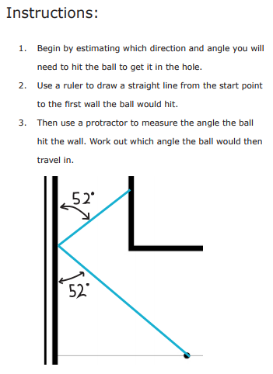
Angle Golf

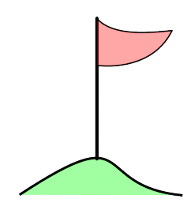
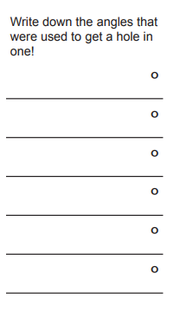
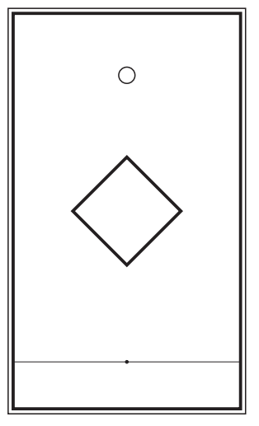
Hole 1

Hole 2
